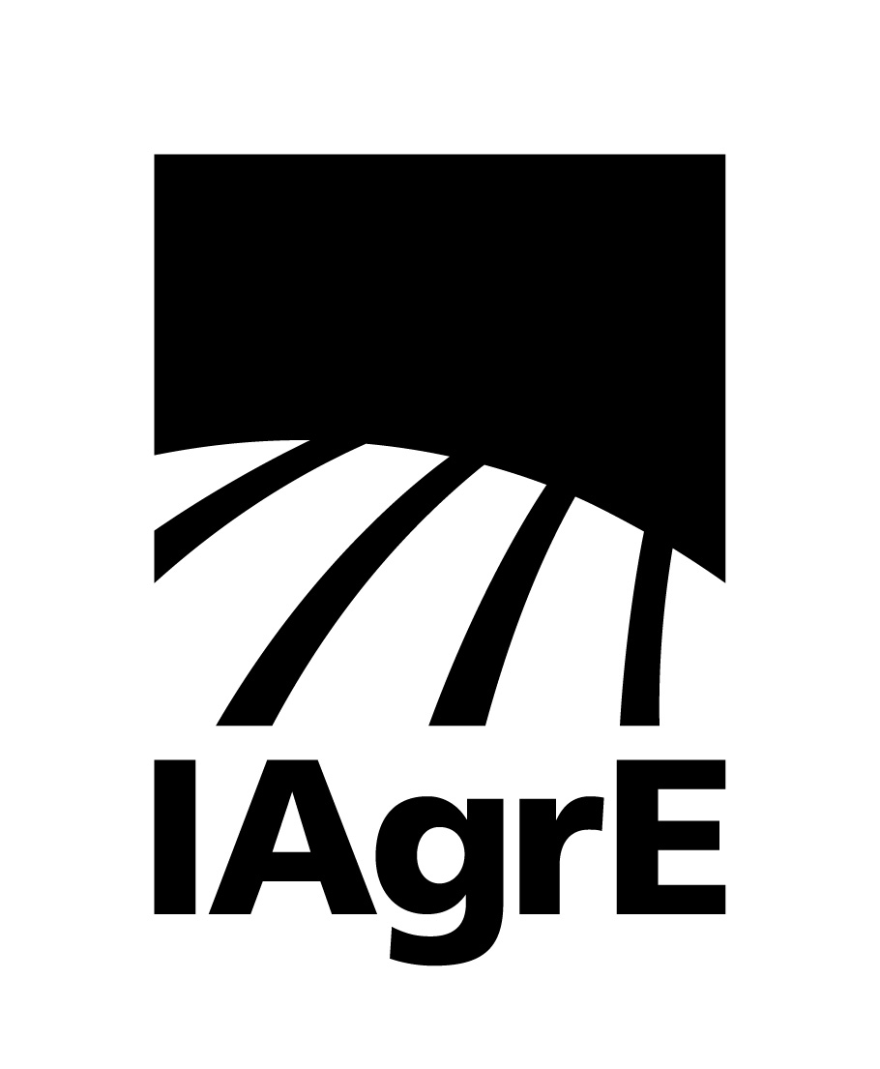

News Release

11 October 2023 Ref: 232

Agricultural Engineering holds the key to feeding the future

With just under 8 billion living on our planet, another 0.5 billion envisaged by the end of the decade and just under 10 billion by 2050 our ability to feed a growing population is a significant task.

A task that will be tackled in this year’s Institution of Agricultural Engineers (IAgrE) annual conference on 1 November 2023 from 10.30 am to 2pm via zoom.

The conference will explore some very different areas, such as farming without soil, advances in harvesting machinery and what technology the horticultural sector has to offer. The presenters will tackle some of the remarkable advances in technology and offer a taste of how our industry is rising to the challenges ahead.

The event will culminate in a panel discussion where the speakers will answer questions from the audience giving them a chance to put their views forward. This conference will be of interest to a broad spectrum of people, including students, academics, technologists and industry engineers.

The presenters:

Will Downie of John Deere will talk about on board harvester nutrient measurement technology

Niels Kortsee - Intelligent Growth Solutions Ltd will look at how a hybrid approach to farming can help agriculture to weather the effects of climate change.

Dr Toby Mottram FRAEng FIAgrE will discuss opportunities in robotic horticulture.

Kirsty Anne Pilcher BSc (Hons) CEnv MIEMA is the Global Sustainability Manager - Decarbonisation at AGCO will explore Global sustainability.

Click here to book your place.

IAgrE:

IAgrE is the professional body for scientists, technologists, engineers, academics, managers and students working in the land-based sector and has an international membership base.

As a licensed body of the Engineering Council (EngC) and a founding Constituent Body of The Society for the Environment (SocEnv), IAgrE registers suitably experienced professionals as Chartered Engineer (CEng), Chartered Environmentalist (CEnv), Incorporated Engineer (IEng), Registered Environmental Practitioner (REnvP) and Engineering Technician (Eng Tech).

For further details, contact Marion King at communications@iagre.org or call 01234 750876 – mobile 07843382362

