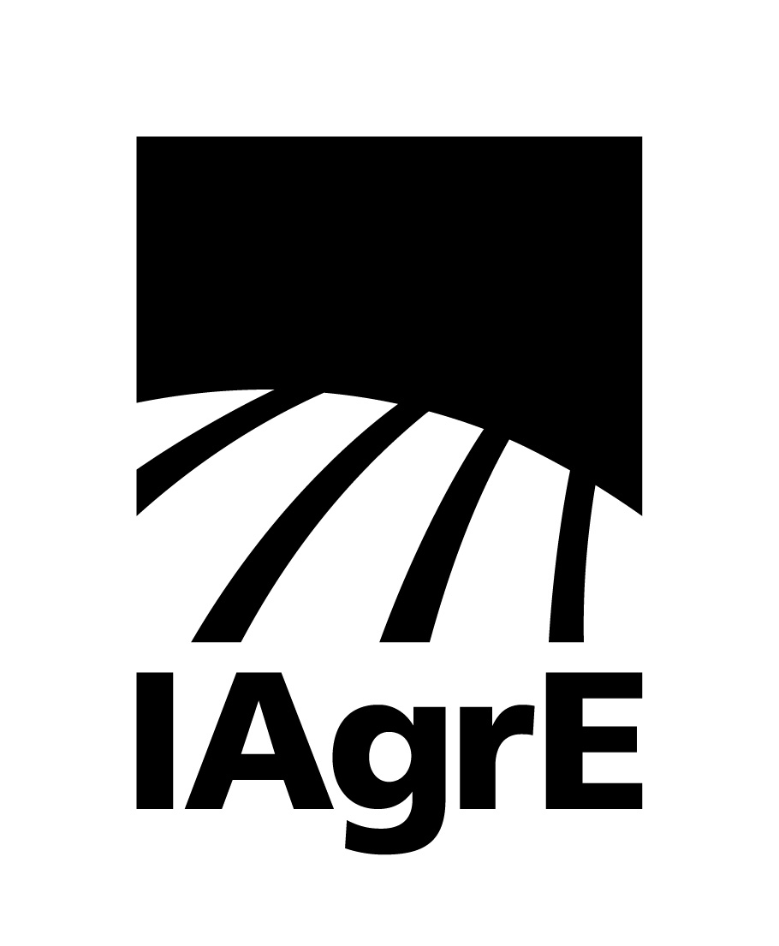

News Release

16 March 2023 Ref: 228

The Institution of Agricultural Engineers (IAgrE) fully supports the new T-Level qualifications for the land-based sector that go live in September 2023

T-Level courses in construction, engineering and manufacturing were launched in 2021 and the Technical Qualifications for Agriculture, Land Management and Production, which includes land-based engineering, will go live from September 2023.

The new T-Levels are technical-based qualifications in England that have been developed with employers and businesses with content that meets the need of industry and prepares students for work, further training or study. These are two-year courses equivalent to 3 A-levels and will eventually replace the National Diplomas in England.

The two year programme will be delivered at local colleges and training providers. The courses will be 80% percent classroom based and 20% practical. Included in the course is a 45 day industry placement, which will give the student valuable workplace experience. The course content will be aligned to the current Level 3 land-based engineering apprenticeship standards.

The government’s Skills for Jobs white paper reforming post 16 further education and skills is at the heart of the plan to create a technical education system. The aim is stronger links between the classroom and workplace, putting employers and standards at the heart of all technical qualifications.

IAgrE CEO Charlie Nicklin commented: “The introduction of T-Levels in England is a great opportunity to refresh full time land-based engineering education which is currently delivered through the existing National Diplomas. The content has been aligned with the well regarded level 3 land-based engineering apprenticeship standards. Involving industry specialists in its compilation ensures that the content is up to date with current technologies. Its important industry gets fully behind the qualifications by supporting the work placements that will help to deliver the future technicians and engineers the sector desperately needs”.

The primary aim of the T-Level learning programme is to provide students with entry to skilled employment within a specific occupation or sector, and to support further higher level training and progression to university. Students will develop occupationally focused skills and knowledge that are valued by employers as essential for employment and the industry placement will help them apply and refine their technical and practical skills, plus knowledge and behaviours to ensure they are ready for the world of work.

They may have been designed for industry by industry but there are concerns that industry is still not demonstrating enough commitment to the roll-out. If this vocational programme is going to succeed it will need the industry’s commitment and backing.

Ends

IAgrE:

IAgrE is the professional body for scientists, technologists, engineers, academics, managers and students working in the land-based sector and has an international membership base.

As a licensed body of the Engineering Council (EngC) and a founding Constituent Body of The Society for the Environment (SocEnv), IAgrE registers suitably experienced professionals as Chartered Engineer (CEng), Chartered Environmentalist (CEnv), Incorporated Engineer (IEng), Registered Environmental Practitioner (REnvP) and Engineering Technician (Eng Tech).

For further details, contact Marion King at communications@iagre.org or call 01234 750876 – mobile 07843382362

